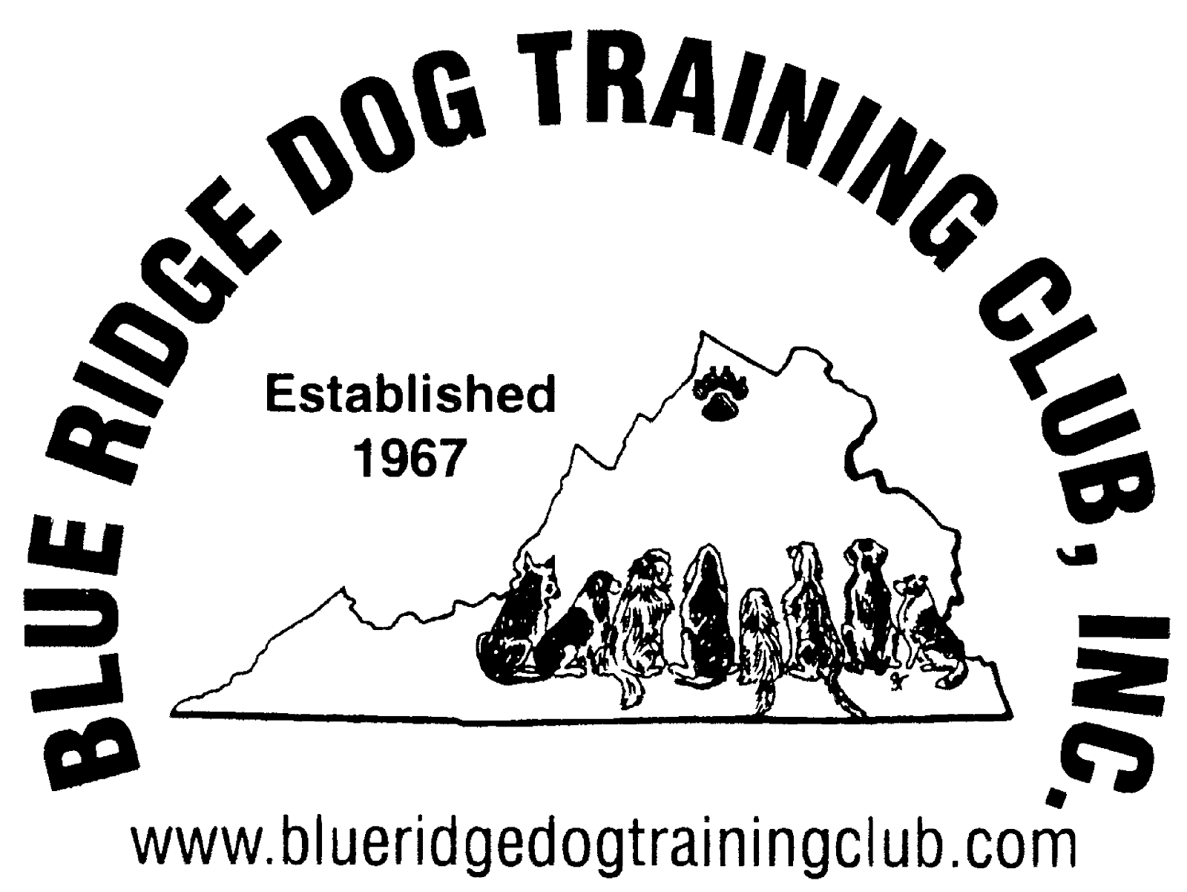
Blue Ridge Dog Training Club

Is sponsoring a
Canine Good Citizen & Therapy Dog International Test
Thursday, May 4th 2017

Blue Ridge Dog Training Club Training Room in the
Body Renew at the Sportsplex of Winchester
221 Commonwealth Court
Winchester, VA 22602

Registrants must pre-register for this test.
Payment will be expected on the day of testing
Please don’t send payment with registration
Please make checks out to BRDTC

CGC testing will begin at 6:00. Testing is conducted individually, specific times will be determined closer to the time of testing.

TDI participants will be tested individually starting at 6:00 pm with 12 testing slots available that night. Individual testing times will be determined closer to testing

To register, email or call or Joy Pitcher at joyfulpitcher@aol.com (email is preferred)/ (540) 532-2970 (please leave message)

* You can also leave a message at the Blue Ridge Dog Training Club line: 540 662-1664

Fees: CGC Test only $ 5.00 for members of Blue Ridge Dog Training Club
$7.00 for non members
TDI Test only $10.00 for members of Blue Ridge Dog Training Club
$15.00 for non members
Same dog CGC and TDI: $12.00 for members of BRDTC
$17.00 for non members

- Dogs must be over 1 year to take the TDI test
- TDI requires dogs have flat buckle collars for testing or non-training harness (no slip leads, prong and other training collars, martingale collars or training harnesses allowed)
- No treats are allowed during testing.
- TDI requires that you present a current rabies certificate and any other state or
locally required inoculation certificates and licenses) with you on the day of testing.
- A dog relieving itself in the building during the test is an automatic fail, so please potty your dog prior to the test.
- Please bring your dog’s AKC number (if you have one) for CGC paperwork
- You should bring a brush for the CGC test

You will notified of your testing time via email, if you need to be informed by phone please indicate on registration form.

Directions to the Body Renew at the Sportsplex building

From the South

- From 81 N. towards Winchester
- Take exit 310 VA-37 toward US 11-VA-642 to Kernstown/US- 50/US- 522/Berkey Springs Romney
- Get into right lane of off ramp and go LEFT at the light onto VA-37 N.
- Take the exit (just after overpass over 81) towards US-11/N Valley Pike
- Turn Right onto Valley Pike
- Take 1st left onto Commonwealth Ct.
- At end of road go left into traffic circle and take 2nd entrance
- Drive into entrance of Body Renew at the Sportsplex parking lot and take immediate left which will take you down a driveway along the back of the Body Renew building.
- Blue Ridge Dog Training Club is the last “Blue” door

From the North

- From 81 S. towards Winchester
- Take exit 310 VA-37 toward US 11/VA-642/Kernstown
- Turn Right onto VA-37
- Take the immediate exit towards US-11/N Valley Pike
- Turn Right onto Valley Pike
- Take 1st left onto Commonwealth Ct.
- At end of road go left into traffic circle and take 2nd entrance
- Drive into entrance of Body Renew at the Sportsplex parking lot and take immediate left which will take you down a driveway along the back of the Body Renew building.
- Blue Ridge Dog Training Club is the last “Blue” door

Preregistration form

Please fill out and return either as an attachment to an email or in the US mail.

Hander’s Name:

Name of person testing with the dog if different-___________ __________

Address

Home phone number _________________ Cell Phone number __________________

Email ________________________

Dog’s Call Name: _____________________

Breed of dog or mix: __________________________ _

Dog’s date of birth/Age (for TDI test, must be 1 year of age): ______________

Are you a member of Blue Ridge Dog Training Club? ___ yes ___ no

I am registering for the following test(s)
Canine Good Citizen Test ____
Therapy Dog International Test ____

Do you have a preference of an early or later test time? ___________________________________

If you have special needs please indicate on this form. Appointment times will be scheduled closer to the date of testing.

